

**Trainee Program Summer 2025**

**TEST ASSIGNMENT**

We did our best to prepare interesting tasks in various modalities for you. There are five of them ☺️ Do not be discouraged, you should **solve only 2 tasks**. Please complete the **first mandatory DL task**, and you may choose the second one yourself. We expect you to select any task in modalities you like most but it is up to you to choose. Have fun!

**Please follow these instructions carefully:**

* Solve mandatory DL tasks and choose **1** of the following **4** tasks. Solve, using Python and any open-source libraries you need;
* Please, make sure your solutions are easy to open, analyze, and run on another computer;
* Make sure your solutions with all materials are less than 1GB for each task (you do not need to include the task data to archive). The smaller your solution - the better.
* Make a separate **.zip archive** for each test-task solution;
* Please, **name the archives “Surname - task X.zip”**, where *Surname* is actually your surname and *X* - the task number.
* Upload your zip archives to the corresponding fields of [the submission form](https://docs.google.com/forms/d/e/1FAIpQLSewVE7MFZjDz7tiz9pa24EGFu0SKUKQLV2sMnedNDqSYlvVzA/viewform?usp=dialog) by **23:59, Tuesday, April 15, 2025.**
* Please, be patient and wait until we check the solutions and send you an email with the results. You will receive the mail after **April 29, 2025**.

Still have questions? Mail to [edu@it-jim.com](mailto:edu@it-jim.com).

Good luck!

# **Task 1 - DL (MANDATORY)**

# **Introduction:**

I bet you’ve already had a chance to try or even started to regularly use one of many modern models or services for image generation. Sometimes, they can generate tricky, funny or simply distorted images. Probably, with human faces it can happen more often than with any regular objects, and we would not want to share them with users of our generation model. In this task you will have to catch such artifacts on our selected generated images, a kind of automatic QA system.

# **Description of the task:**

There is a dataset of generated images. Some of the generated images contain different kinds of artifacts that include but are not limited to text, hands, fingers, pieces of face masks, tattoos, eyes not looking at the camera, etc. This task is a kaggle-like challenge to train the best possible model for binary images classification.

# **Requirements:**

* Your code should provide functions to train, validate and infer the model.
* You should calculate a single required metric: micro F1 score. Other metrics are optional and can be utilized at your own discretion.
* [Advanced] You can provide a few different approaches (not just different model versions) and try to combine them into an ensemble solution

# **Input data [**[**link**](https://drive.google.com/file/d/1aGBQcvCIZ4f-tzMjSvWaNp1OxdOtZDYj/view?usp=sharing)**]:**

There are two directories with 1800 train and 200 test images. All files are named using this template

image_<frame_index>_<class label>.png. Class label can be either 0 or 1 which corresponds to artefact and artefactless images respectively.

Below there are examples of two classes.

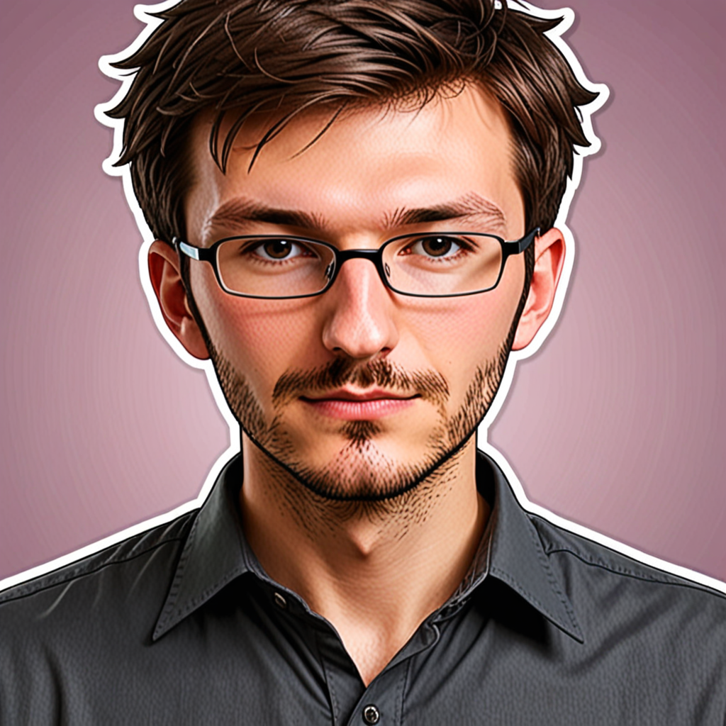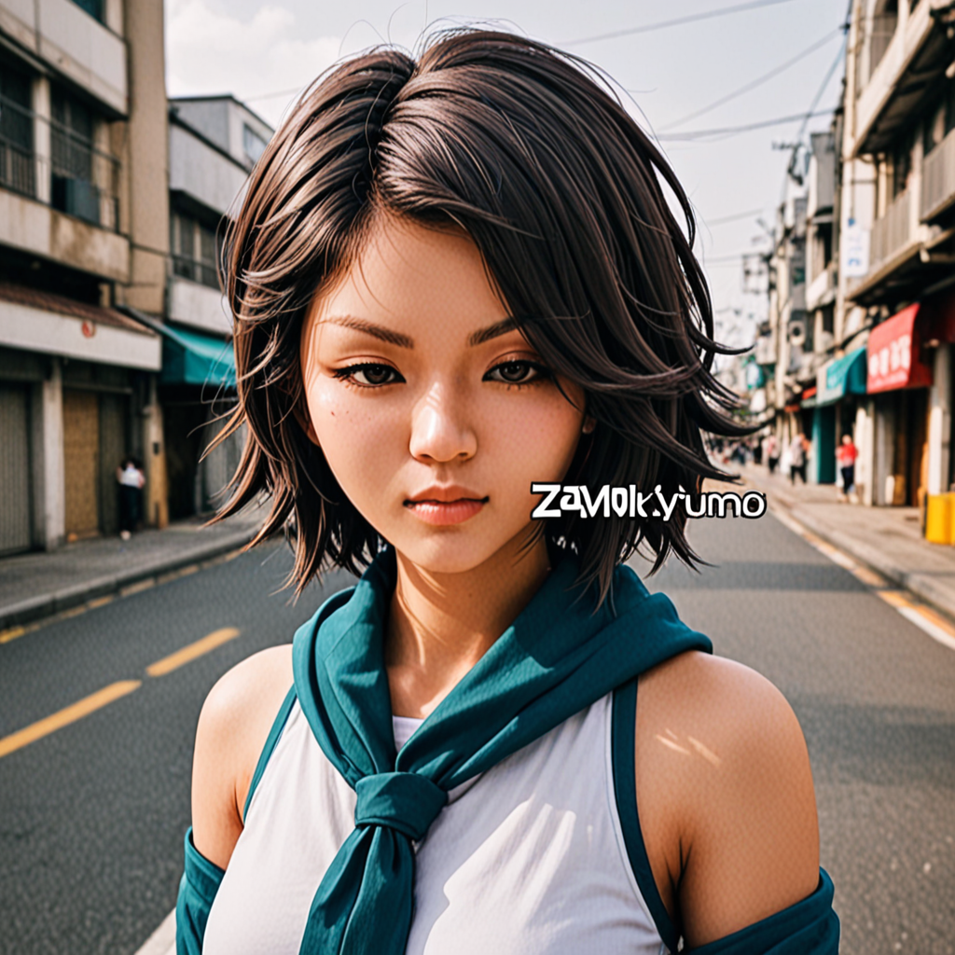

# **Deliverables:**

* Either
  + Notebook with organized code and commentaries on the process of development of your solution (EDA, hypothesis checks, training experiments, finetuning, conclusions etc)
  + Structured and organized python code with separation into modules, utils, classes etc. along with a separate document that describes and illustrates the process of development of your solution
* *Requirements.txt* or *environment.yml*
* **README.md** with description of your solution, guide how to use it, and final metrics.

# **Notes**

* You can use Google Colab or Kaggle free access GPUs, if you do not have a machine with an Nvidia GPU or Mac with ARM chips.
* There is a lot of information we can extract from faces.

# **Task 2 - (OPTIONAL) Classic CV - Drone navigation**

# **Introduction:**

If you ever thought of flying drones that can be resistant to electronic warfare, this task can give you an idea how to build an autonomous navigation system for UAV.

# **Description of the task:**

Given a satellite panoramic image of an area where an unknown good UAV should have flown and a series of photos taken from the UAV during its flight, you should reconstruct and visualise its route.

# **Requirements:**

* The code should read a region map and series of “frames” from specified paths
* The output should be either a single image with a trajectory or a video with a trajectory and real-time moving position of the UAV.

# **Input data [**[**link**](https://drive.google.com/file/d/1h6xfYQfokDo5AzSv1Q-x66HluDpWSh87/view?usp=sharing)**]:**

* Panoramic satellite map of the area of interest
* 50 consecutive “photos” from the UAV (we imitate it with satellite image taken at a proper angle and at another scale)

Satellite area map example:  
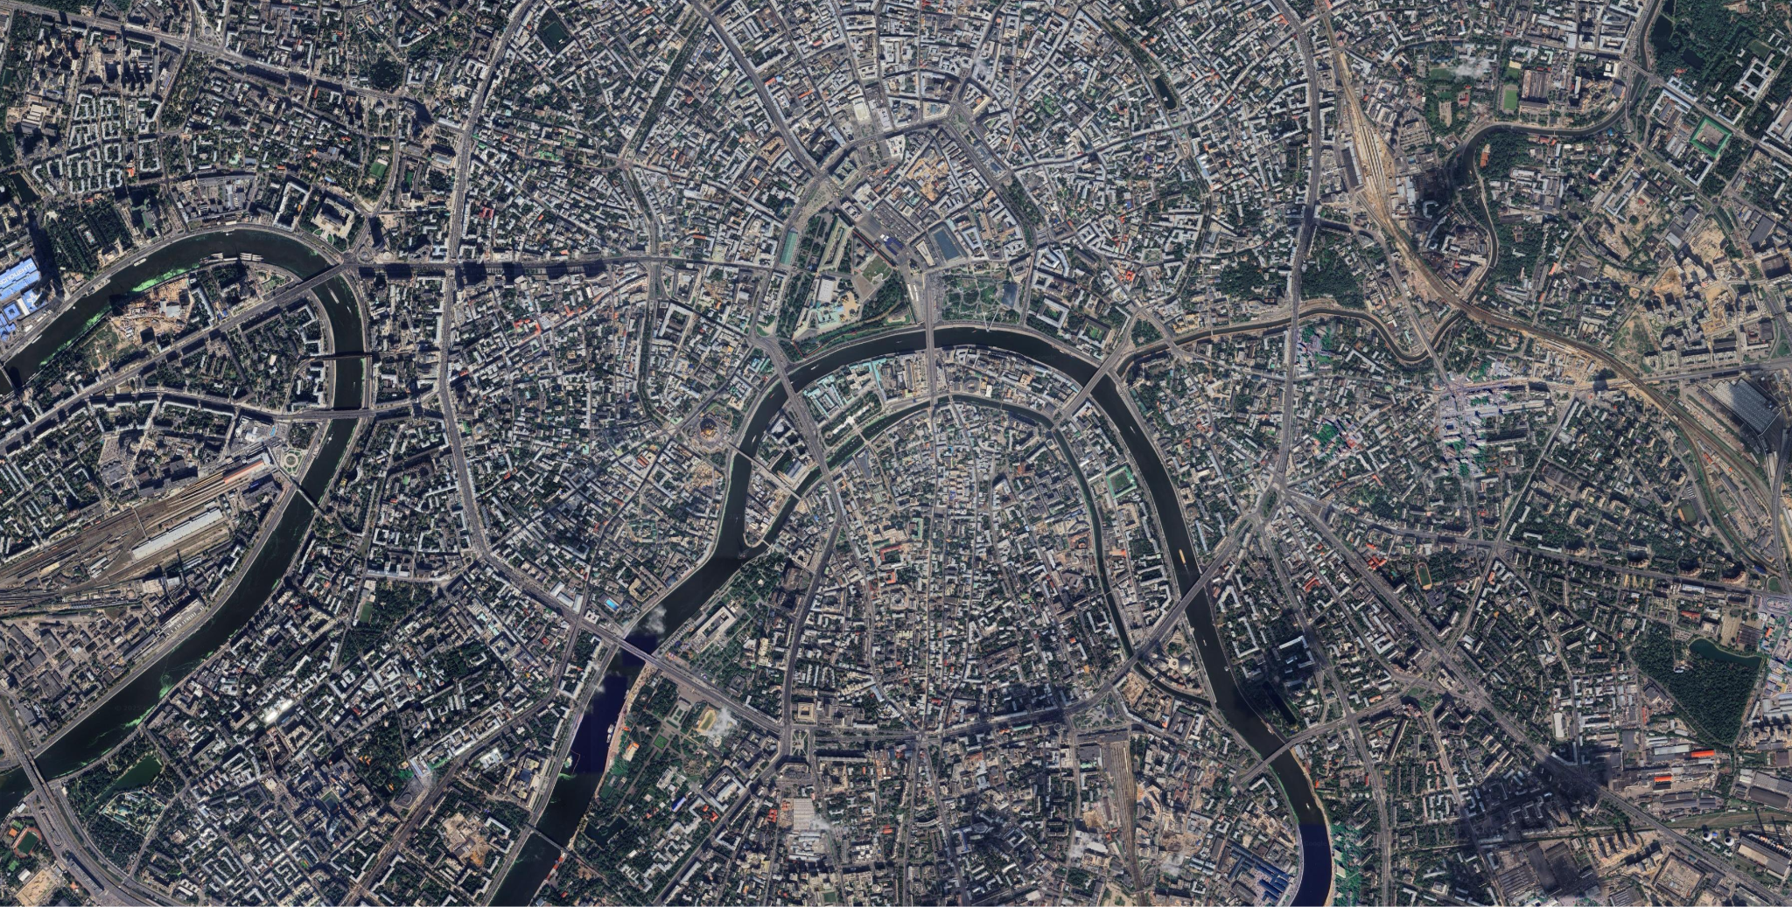

Drone photo example:

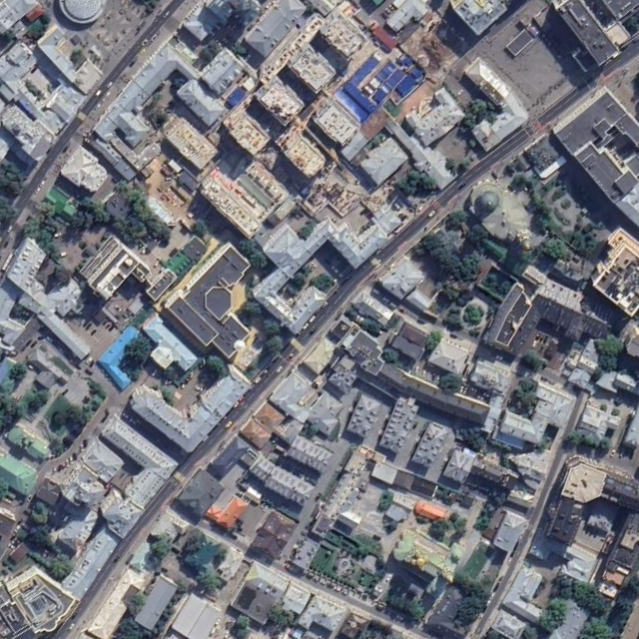

A rough example how visualization should look like:

# **Deliverables:**

* Well organized and commented code
* Requirements.txt or environment.yml
* README.md with basic description of your solution
* An image with a map and visualized route with information about start/finish and order of route points

# **Notes**

* Use trajectory interpolation and smoothing (if needed)
* Optionally for final results visualization you can make a video with zoomed in map region and per-frame trajectory visualization
* Optionally for ideal visualization on the image you can show bounding boxes of “photos” taken from the drone with preservation of their size and rotation.

# **Task 3 - (OPTIONAL) Audio**

# **Introduction:**

Ever asked someone what kind of music they’re into and heard the classic “I love all genres”? It’s a vibe, but it often says more about how we store our music than what we actually listen to. Most people throw all their favorite songs into one giant, ever-growing library. Some get organized and build playlists — by mood, moment, decade, genre, origin, or even weather.

But what if we didn’t have to organize it all ourselves? What if we had a smart tool that could automatically cluster our music into playlists based on how it sounds? Sounds good, right? Well, in this task you’ll be building the first step toward that — a tool that groups music purely based on audio similarity. Let’s dive in.

# **Description of the task:**

Your task is to create two versions of a Python program that clusters songs into playlists based on their sound similarity. Both versions should take as input a path to a folder containing music files and the number of playlists to generate, and output playlists with songs grouped by style.

* Version 1: Use only algorithmically computed features (e.g., MFCCs, tempo, etc.).
* Version 2: Use deep learning-based features extracted from an open-source model of your choice.

Each version should generate a .json file with playlists and print log progress from start to finish.

## Input data:

Here is a [**[link]**](https://drive.google.com/file/d/1QjZGbIyJ7NqX7bsxgGtY8JaE4CmgEj3a/view?usp=drive_link) to the dataset containing songs for clustering

# **Requirements:**

* Code must be written in Python
* Two versions:
  + main_v1.py for the classical features approach
  + main_v2.py for the DL-based approach
* CLI-compatible: scripts should accept the following arguments:
  + --path (path to the folder with songs)
  + --n (number of playlists/clusters)
* Logging: logs should be printed and indicate process start and end
* Output files:
  + playlists_v1.json and playlists_v2.json, structured like this:

"playlists": [

{

"id": 0,

"songs": ["song_id", "song_id" ...]

},

{

"id": 1,

"songs": ["song_id" ...]

}

// ...

]

}

* Include a report (PDF) that explains:
  + Your approach in both versions
  + Research process and reasoning behind chosen methods
  + Observations and conclusions from results
* Include requirements.txt to recreate the code environment
* Any model weights or resources needed to run the code should be included

# 

# **Deliverables:**

* Python code that satisfies all the requirements
* requirements.txt file
* playlists_v1.json and playlists_v2.json outputs from provided dataset with 3 clusters
* PDF report
* Any additional resources needed to run your solution (e.g., model weights)

# **Task 4 - (OPTIONAL) GenAI**

# **Introduction:**

Remember the last time you took a group photo with more than three people? What is the biggest challenge of this process? In our opinion, it’s to make every single person not blink and pretend that they enjoy their life. While we can’t physically help with such stuff (unless you are open to some [extreme approaches](https://cdn.mos.cms.futurecdn.net/9gVC9BkfBNdvHiQ4sSrB7F.jpg)), we can fix bad photos using some cool techniques, including Visual Gen AI ones.

# **Description of the task:**

Your task is to create an automatic pipeline that:

1. Detects human faces and analyzes their expressions on the input image.
2. Fixes eyes if they are considered closed (and possibly mouth, if it’s not happy enough).

## Input data [[link](https://drive.google.com/drive/folders/12j0DIoEONNHcvg-zmxZAa_Gfxy2Mws_E?usp=sharing)]:

You can use either the provided photos or any other you like, no restrictions here.

# **Requirements:**

* **[Optimal]** An automated pipeline that takes as input an image and fixes face expression without losing the face resemblance.
* **[Advanced]** Implement 2+ different approaches that can be selected during the code launching (for example, simple inpainting and some face-specific approach).
* **[Optional]** Create a simple Gradio demo where we can upload the photo, select the approach, and see the output photo. You can also add some other settings you find useful. This is completely optional, you can write the interface only if it will not harm the mandatory task.

# **Deliverables:**

* Well-structured & organized code following the given structure:

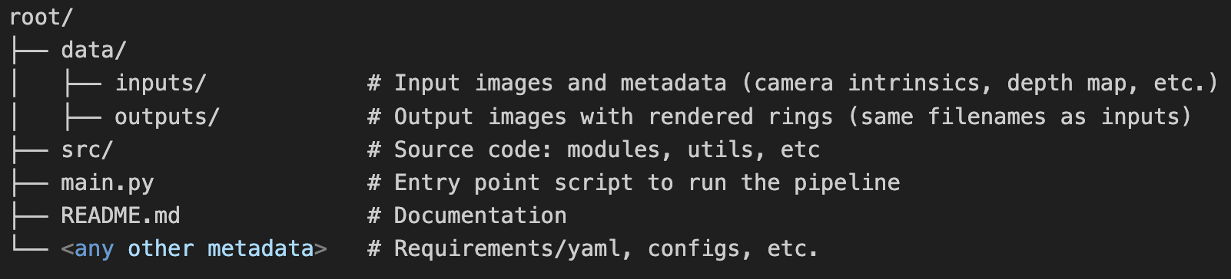

* **README.md** must include:
  + Installation instructions.
  + Usage example.
  + Brief description of the solution and technologies/techniques used.
* Output images in **data/outputs.**

# **Task 5 - (OPTIONAL) 3D CV**

## Introduction:

This task focuses on creating a computer vision solution that places a 3D ring model onto a hand in a given image. Instead of real-time AR, the system should work with provided data to visualize how a ring would look on a specific finger.

## Description of the task:

Given an image of a hand and a 3D model of a ring, the task is to estimate the 6DoF pose of the target finger relative to the camera, and render the ring in the correct position and orientation. The solution should leverage hand landmark detection and utilize additional prior data including camera intrinsics, a depth map, and/or canonical hand topology.

## Input data [[link](https://drive.google.com/file/d/1r22pB7bfN9c7fWfJUuwM_J0u1MvLhqTV/view?usp=sharing)]:

| * Target: index finger. * 3D model (.obj/.glb) of a ring [in mm]. * Validation data: 5 images. * ARKit logs for each validation sample:   + camera intrinsic;   + depth map [in m]. * Hand landmarks canonical measurements [in mm]. | *Try-On Target Position* |
| --- | --- |

|  |  |  |
| --- | --- | --- |
| *RGB image* | *Depth map* | *Meta: intrinsics, canonical hand topology. 3D ring model* |
| *Input sample data demonstration* | | |

## Requirements:

* **[Minimum]** Item is correctly augmented within a finger and rendered.
* **[Optimal]** In addition to minimum requirements, it introduces a realistic rendering with correct visibility of a “back” side of a ring for any angle of a finger. It also might include such features as re-lightning.

## Deliverables:

* Well-structured & organized code following given structure:



* **README.md** must include:
  + Installation instructions.
  + Usage example.
  + Brief description of the solution and technologies/techniques used.
* Output images in **data/outputs**.